**module RAM_16x8_ex2 (clk, CS, W, R, addr, i_data, o_data);**

**input clk;**

**input CS, W, R;**

**input [3:0] addr;**

**input [7:0] i_data;**

**output reg [7:0] o_data;**

**reg [7:0] Mem [0:15];**

**always @ (CS or W or R or posedge clk)**

**if(CS && W)**

**Mem[addr] <= i_data;**

**else if (CS && R)**

**o_data <= Mem[addr];**

**initial //initializing Mem**

**$readmemh ("memory.dat", Mem);**

**Initial //Displaying the data read from Mem**

**$monitor ($time, " %h", o_data);**

**endmodule**

**//memory.dat. The .dat file must be in the same directory as design and testbench. Otherwise you will need to specify the complete path.**

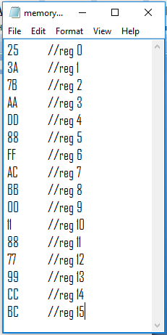

**module RAM_16x8_ex2_testbench();**

**reg clk;**

**reg [3:0] address;**

**reg CE, write, read;**

**reg [7:0] data_in;**

**wire [7:0] data_out;**

**RAM_16x8_ex2 ram1 (**

**.clk(clk),**

**.addr(address),**

**.CS (CE),**

**.W(write),**

**.R(read),**

**.i_data(data_in),**

**.o_data(data_out));**

**initial begin**

**$display("Reading from Memory (already initialized/populated using $readmemh)...");**

**clk = 1;**

**CE = 0;**

**read = 0;**

**#10 read = 1;**

**#50 CE = 1;**

**#10 address = 15;**

**#10 address = 1;**

**#10 address = 2;**

**#10 address = 3;**

**#10 address = 7;**

**#10 address = 6;**

**#10 address = 5;**

**#10 address = 4;**

**#10 address = 8;**

**#10 address = 9;**

**#10 address = 10;**

**#10 address = 11;**

**#10 address = 0;**

**#10 address = 14;**

**#10 address = 13;**

**#10 address = 12;**

**#500 $finish;**

**end**

**always begin**

**#5 clk = ~clk; end**

**endmodule**

